Hands On: AWS VPC Essentials
(Part – 4)
AWS Transit Gateway

Transit Gateway is a network transit hub that you can use to interconnect your virtual private clouds (VPCs) and on-premises networks.
- Transit Gateway uses a hub-and-spoke model to connect multiple VPCs and on-premises networks.
- You do not need additional transit gateways for high availability, because transit gateways are highly available by design.
- For redundancy, use a single transit gateway in each Region for disaster recovery.
- Each VPC attachment is associated with a single route table. That route table decides the next hop for the traffic coming from that resource attachment.
- When you attach a VPC or create a VPN connection on a transit gateway, the attachment is associated with the default route table of the transit gateway.

- Transit gateway peering attachments support static routing only. You can point routes in transit gateway route tables to the peering attachment for routing traffic between the peered transit gateways.

- Attachments with regards to the AWS Transit Gateway refer to the associations between the Transit Gateway and other network resources, like VPCs and VPN associations. Connections empower traffic to stream between the Transit Gateway and the attached resources.

- AWS Transit Gateway improves as your network grows and requires connections to more VPCs or on-premises networks. It simplifies network management by providing a centralized hub for routing and security policies.

Hands-On

In this Hands-on session, provides solution for creates a transit gateway in each Region and then configures the transit gateways and route tables to support inter-Region communication between the target VPCs, which are in the same account.

Ref: https://docs.aws.amazon.com/prescriptive-guidance/latest/patterns/peer-vpcs-different-regions-transit-gateway.html

Architectural Diagram

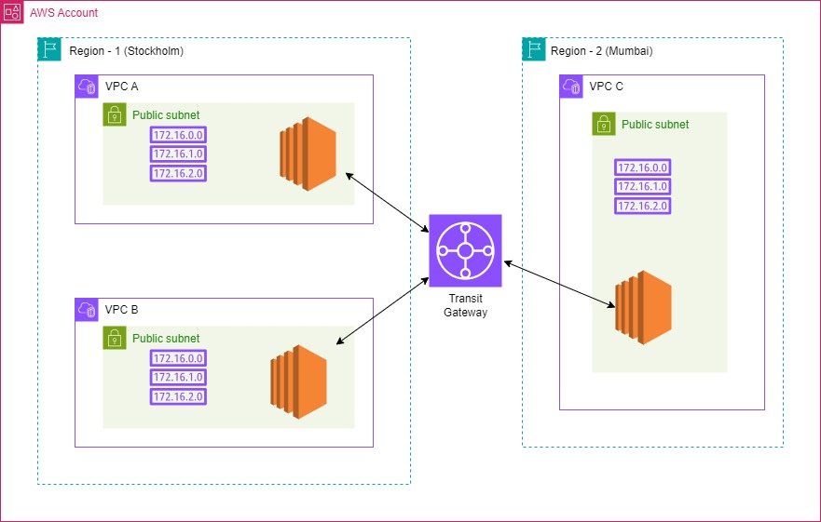

Steps:

1.Configure VPC’s

- VPC A – 10.0.0.0/16 – eu-north-1(Stockholm)
VPC B – 11.0.0.0/16 – eu-north-1(Stockholm)
VPC C – 12.0.0.0/16 – ap-south-1(Mumbai)
- Each VPC has an EC2 instance in public subnet. Attach an Internet gateway to the subnet for accessing these instances through SSH.

- Configure each EC2 instances in a security group by allow SSH traffic from anywhere ipv4 and ALL ICMP from other VPC’s CIDR ranges.

- Configure Route tables for each VPC’s public subnets, with an internal route and to internet access destination through corresponding IGW’s.

- For VPC A
Public subnet: vpc-a-subnet:10.0.1.0/24
IGW: vpc-a-igw
EC2: vpc-a-ec2
Security group: vpc-a-sg; allow ssh from 0.0.0.0/0 and ICMP from 11.0.0.0/16 and 12.0.0.0/16
Route table: vpc-a-rt
Destination Target
0.0.0.0/0 vpc-a-igw
10.0.0.0/16 internal

- For VPC B
Public subnet: vpc-b-subnet:11.0.1.0/24
IGW: vpc-b-igw
EC2: vpc-b-ec2
Security group: vpc-b-sg; allow ssh from 0.0.0.0/0 and ICMP from 11.0.0.0/16 and 12.0.0.0/16
Route table: vpc-b-rt
Destination Target
0.0.0.0/0 vpc-b-igw
11.0.0.0/16 internal

- For VPC C
Public subnet: vpc-c-subnet:12.0.1.0/24
IGW: vpc-c-igw
EC2: vpc-c-ec2
Security group: vpc-c-sg; allow ssh from 0.0.0.0/0 and ICMP from 11.0.0.0/16 and 12.0.0.0/16

Route table: vpc-b-rt
Destination Target
0.0.0.0/0 vpc-b-igw
11.0.0.0/16 internal

2. Create a transit gateway in each Region

- Open the Amazon VPC console
- In the Region selector, choose the Region - eu-north-1(Stockholm) for TGW in region-1
- On the navigation pane, choose Transit Gateways - Create transit gateway.
- For Name tag: tgw-stockholm
- In Configure the transit gateway section, do the following:
For Amazon side Autonomous System Number (ASN), leave as AWS choose.

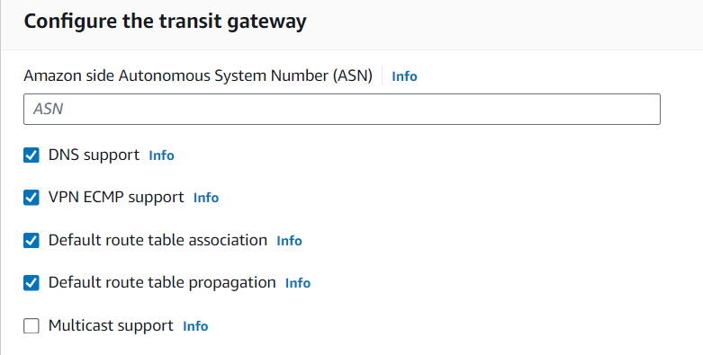
- Leave the other options as default as the above snap.
- Choose Create transit gateway. When the gateway is created, the initial state of the transit gateway is pending.
- Repeat the previous step to create a transit gateway in region 2-ap-south-1(Mumbai) – tgw-mumbai.
3. Create an attachment for each VPC.
- Amazon VPC console - choose Transit Gateway Attachments.
- Choose Create transit gateway attachment.
- Name tag – tgw-attachment-vpc-a
- For Transit gateway ID, choose the transit gateway to use for the attachment.
- For Attachment type, choose VPC.
- Choose whether to enable DNS support. For this exercise, do not enable IPv6 support.
- For VPC ID, choose the VPC to attach to the transit gateway (VPC ID of vpc-a)
- For Subnet IDs, select one subnet for each Availability Zone to be used by the transit gateway to route traffic
- Choose Create transit gateway attachment.
- Repeat the previous step to create a VPC attachment for the transit gateway for vpc b - tgw-attachment-vpc-b.
- Also create VPC attachment for vpc c (tgw-attachment-vpc-b) to the transit gateway in region 2(Mumbai) – tgw-mumbai.

4. Enable Transit Gateway Peering
- Open the VPC console
- In the Region selector, choose Region 1 – Stockholm
- In the navigation pane, choose Transit Gateway Attachments.
- Choose Create transit gateway attachment.
- For Transit gateway ID, choose the transit gateway that you created in region 1: tgw-stockholm
- For Attachment type, choose Peering Connection.
- For Account, choose My account.
- For Region, choose Region 2.
- For Transit gateway (accepter), enter the ID of the transit gateway in Region 2 - Mumbai.
- Choose Create transit gateway attachment.

Accept the peering attachment request:
- Open the VPC Console
- In the Region selector, choose Region 2.
- In the navigation pane, choose Transit Gateway Attachments.
- Select the transit gateway peering attachment that is pending acceptance.
- Choose Actions, and then choose Accept transit gateway attachment.

5. Update VPC Route Tables
For vpc-a-rt
- VPC Console - Region selector, choose Region 1 – Stockholm.
- In the navigation pane, choose Route tables.
- Select the route table - vpc-a-rt
- Choose Actions, and then choose Edit routes.
- Choose Add route.
- For Destination, enter the CIDR block of the vpc-b in region 1 and vpc-c in region 2.
- For Target, choose Transit Gateway, and then enter the ID of the transit gateway in region 1 - tgw-stockholm
- Choose Save changes.

For vpc-b-rt
- For Destination, enter the CIDR block of the vpc-a in region 1 and vpc-c in region 2.
- For Target, choose Transit Gateway, and then enter the ID of the transit gateway in region 1 - tgw-stockholm.

For vpc-c-rt
- For Destination, enter the CIDR block of the vpc-a and vpc-b in region 1-stockholm.
- For Target, choose Transit Gateway, and then enter the ID of the transit gateway in region 2 - tgw-mumbai.

6. Transit Gateway Route tables

Configure the transit gateway route table in Stockholm region

- In the navigation pane, choose Transit gateway route tables.
- Select the route table used by the transit gateway in region 1 - Stockholm.
- Choose Actions, and then choose Create static route.
- On the Create static route page, enter the CIDR block (12.0.0.0/16) for the VPC in Region 2 - Mumbai.
- For attachment, choose the peering attachment between both transit gateways - tgw-attachment-stockholm-mumbai
- Choose Create static route.

Configure the transit gateway route table in Stockholm region

- In the navigation pane, choose Transit gateway route tables.
- Select the route table used by the transit gateway in region 1 - Stockholm.
- Choose Actions, and then choose Create static route.
- On the Create static route page, enter the CIDR block of vpc-a (10.0.0.0/16) and vpc-b (11.0.0.0/16) for the VPC’s in Region 1 - Stockholm
- For attachment, choose the peering attachment between both transit gateways - tgw-attachment-stockholm-mumbai
- Choose Create static route.

7. Verify Connectivity

- Connect ssh to instances in the public subnets of vpc-a, vpc-b and vpc-c.
- Ping from each instance to the private IP of the other instances.
- Confirm that the ping was successful. This validates that the peering connection has been established between the two VPCs in different Regions.

Troubleshoot:
- Verify that the security groups attached to the instances allow ICMPv4 inbound pings from the appropriate CIDR blocks
- Verify that the VPC route table has a route to the other CIDR block. The route should point toward the transit gateway as the next-hop.
- Verify that the transit gateway route table has a route to the other CIDR block. The route should point toward the peering attachment as the next-hop.

